Structured Dataset

What is Structured Dataset
# Source: AI Source: Provided by: [Data Path: Persons Table -> ID Column: 1, Name_En Column: Motasem Essam] -> From: [Chatgpt (GPT‑5 Mini)] on [12/10/2025]
A structured dataset is a collection of data that is organized in a clear, predefined format, usually in rows and columns. This makes it easy for computers and humans to store, query, and analyze the data.

Key Characteristics of Structured Datasets
# Source: AI Source: Provided by: [Data Path: Persons Table -> ID Column: 1, Name_En Column: Motasem Essam] -> From: [Chatgpt (GPT‑5 Mini)] on [12/10/2025]
- Predefined Schema
  - Each column has a specific data type (e.g., integer, float, string, date).
  - Example columns: Name (string), Age (integer), Salary (float)
- Organized in Tables
  - Data is stored in rows and columns (like spreadsheets or relational databases).
- Easily Queryable
  - Can be accessed using SQL or similar query languages.
- Consistent Format
  - Each record (row) follows the same structure.

Examples of Structured Datasets
# Source: AI Source: Provided by: [Data Path: Persons Table -> ID Column: 1, Name_En Column: Motasem Essam] -> From: [Chatgpt (GPT‑5 Mini)] on [12/10/2025]
Example 1 – Student Records
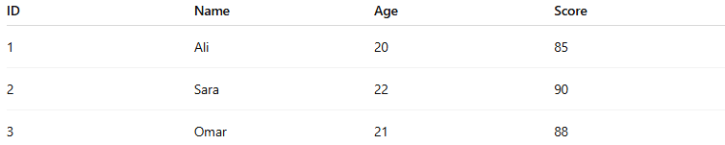
ID | Name | Age | Score
1 | Ali | 20 | 85
2 | Sara | 22 | 90
3 | Omar | 21 | 88
- Columns: ID, Name, Age, Score
- Rows: Each student’s record
Example 2 – Sales Data
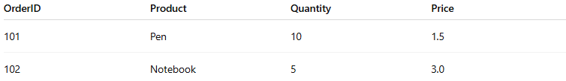
OrderID | Product | Quantity | Price
101 | Pen | 10 | 1.5
102 | Notebook | 5 | 3.0

Where Structured Datasets Are Used
# Source: AI Source: Provided by: [Data Path: Persons Table -> ID Column: 1, Name_En Column: Motasem Essam] -> From: [Chatgpt (GPT‑5 Mini)] on [12/10/2025]
- Relational databases (MySQL, PostgreSQL, Oracle)
- Spreadsheets (Excel, Google Sheets)
- Business reports and analytics

Advantages
# Source: AI Source: Provided by: [Data Path: Persons Table -> ID Column: 1, Name_En Column: Motasem Essam] -> From: [Chatgpt (GPT‑5 Mini)] on [12/10/2025]
- Easy to store, query, and analyze.
- Works well with data analysis tools and SQL queries.
- Ideal for numerical and categorical data.

Disadvantages
# Source: AI Source: Provided by: [Data Path: Persons Table -> ID Column: 1, Name_En Column: Motasem Essam] -> From: [Chatgpt (GPT‑5 Mini)] on [12/10/2025]
- Not flexible for unstructured or complex data like images, videos, or social media posts.
- Schema must be defined in advance.

✅ In simple terms:
# Source: AI Source: Provided by: [Data Path: Persons Table -> ID Column: 1, Name_En Column: Motasem Essam] -> From: [Chatgpt (GPT‑5 Mini)] on [12/10/2025]
A structured dataset is a table of organized data with rows and columns, making it easy to process and analyze.

